July 2009
Issue 9
Safety Matters

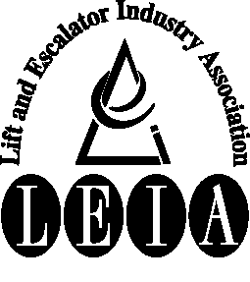
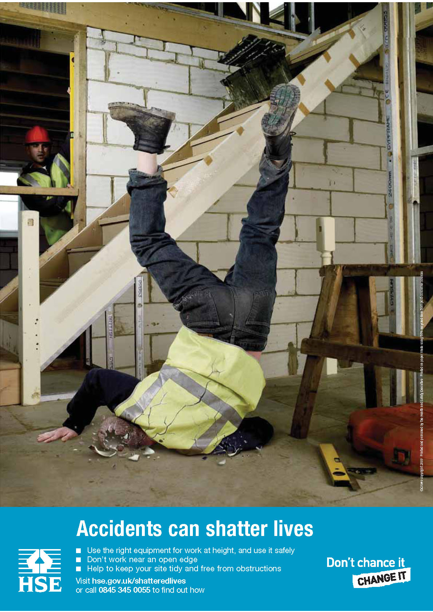
Articles:

• Shattered Lives

• Common Accidents

- Extension Leads

Tel: 020 7935 3013
Fax: 020 7935 3321
Email: enquiries@leia.co.uk
Welcome to the July 2009 edition of Safety Matters.
Through this newsletter our aim is to inform you of health and safety issues that may have an impact on the Lift & Escalator industry. Safety Matters is also available for download from the LEIA member’s website. www.leia.co.uk

Introduction

Shattered Lives

Overleaf we have highlighted two incidents that fall within this campaign.

Rather than repeat what is already freely available it was felt that it would be more useful to pass on what resources and information is available on-line.

The main place to look for safety information is on the HSE website at www.hse.gov.uk You will find not only information on health and safety issues but also resources such as training packs and slide shows.

For specific information and resources on the Shattered Lives campaign information can be found at: http://www.hse.gov.uk/shatteredlives/index.htm

Two elearning packs are available on the HSE website:

STEP eTool
STEP is an eLearning package developed by the HSE, providing slips and trips guidance through interactive learning.
and

WAIT eTool - launching summer 2009
Aimed at the occasional user of access equipment, WAIT will help you choose the safest type of access equipment, if you need to work at height.

Recently in the press and on television information has been given on the HSE campaign ‘Shattered Lives. This is the second time the HSE have run the campaign in an effort to drive down the accidents that occur and raise awareness on the impact an accident can have not only to the company but also the family.

Every month over a thousand people suffer serious injuries as a result of slips, trips or falls in the workplace. These shattering injuries can be avoided by sensible and proportionate management of the risks.

Accident Awareness
In this edition of Safety Matters there are two examples of accidents, one construction and one maintenance, where the incident had the potential to be much worse than the actual outcome. Both may seem trivial but both could have resulted in a serious injury. Both happened in fairly routine circumstances which are encountered daily.

Nº 1

WHAT HAPPENED
Engineer carrying out routine maintenance and was moving from landing to landing via the stairwell to carry out various landing checks. On leaving one landing he slipped and fell 3-4 steps. Although cleaning had been in progress and the floor was wet there was no warning of this fact.

Nº 2

WHAT HAPPENED
During escalator installation engineer was using maintenance staircase between the machinery to collect tools.

As he was making his way down he missed his footing and fell resulting in an ankle injury. The staircase was part of the build and the handrail had yet to be installed but the escalator truss could have been used to provide support.

CAUSE:
- Wet floor
- Unsuitable flat surface
- No warning signs
- Lack of appreciation of the risk presented by the wet floor as this was a daily routine.

CAUSE:
- No handrail fitted
- Escalator truss not used for support as an alternative to a handrail.
- Engineer may have been distracted as he was going down the stairs

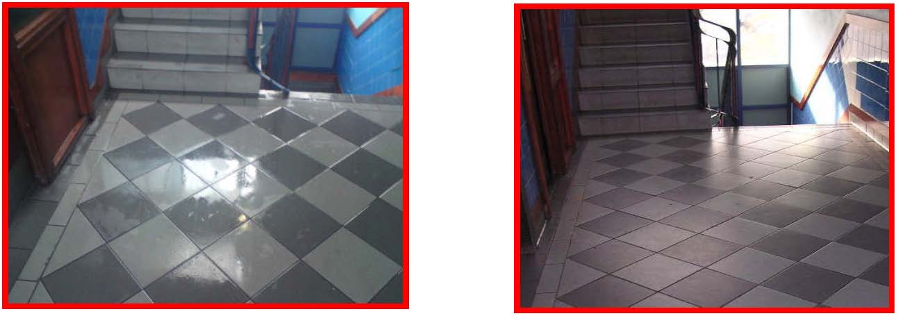
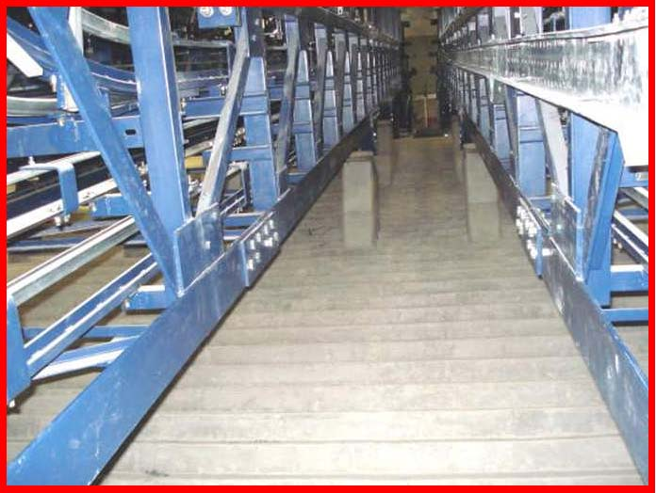
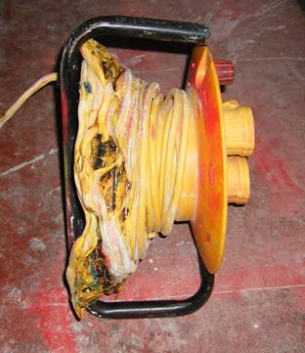
The picture to the right shows what can happen if an extension lead is left coiled on its reel when in use.

Heat will be generated in the coiled cable to the point where the insulation starts to melt and a fire may result. Unfortunately any electrical safety trip device fitted may not detect this situation until it is too late.

Always read the instructions provided with the extension and ensure that the cable is fully uncoiled before use.
The above are two common areas – stairs and floors – where slips, trips and falls most commonly occur. Be aware these everyday areas are connected with many accidents some of which result in serious injury.

Extension Leads

